**Excel to Access Database Updater**

The EADU is a program that updates the **Globalist** Database **PartFirstTestFileVersion** and **PartFinalTestFileVersion** columns with the corresponding TestFile versions pulled from the TTA and TTZ files for that part. The required information is gathered from the CURRENT folder containing live TestFiles used in production.

To operate the program, browse to the Database that you wish to update. You should see the location of the selected Database in the text box. Once selected, connect to the Database using the button available; upon successful connection, you should see a message confirming a successful connection to the Database and the total number of records to be updated. Otherwise, you’ll see a message saying an error occurred in the connection. Ensure that the Database is in the correct location you selected. Following a successful connection, press “Initiate Update” to start.

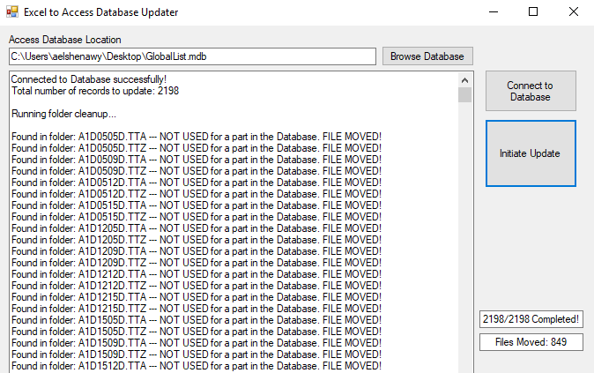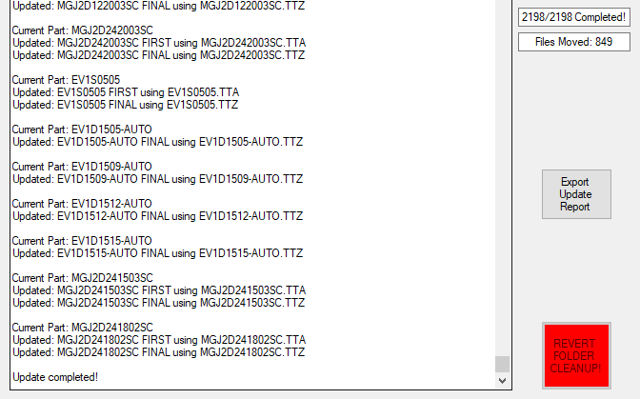The program starts off by initiating a folder clean up process. Any file in the CURRENT folder that has no corresponding part in the Database will be removed from the folder and will be replaced in the “Unused TestFiles” folder which sits right above CURRENT. It will be apparent when and which files were removed as seen below.

The exact total number of TestFiles removed can be seen from the program including full TestFile names. Following the cleanup process, the program starts updating the Database with the file versions as mentioned previously. A message will appear that the update has been completed. In addition, a progress meter is available that displays the progress of the update.

For log-keeping purposes, it is advised that you export the update report for records. The Update Report will be automatically saved in:

**\\mk-testeng\TestEng\HSTDATA\HST\TESTFILE\MASTERS\EADU Exported Database Update Reports**

**NOTE:** Please DON’T rename the beginning of the Update Reports text file as that is monitored by the program. If it’s necessary to edit the report names, append them as a suffix.

In the scenario that a **PartFile** entry needs to be edited in the Database to work with a new file, if the program doesn’t find a matching **PartFile** entry for that old TestFile, the file will be removed from the CURRENT folder. When the old **PartFile** name is ready to be re-used again, click the “Revert Folder Cleanup” to move all files back to the CURRENT folder. When you start the update again, the program will detect the new files and run the cleanup again, removing them as appropriate. Do not manually copy files back and forth to prevent error.

Any questions regarding the program, please speak to Amr Elshenawy or Peter Abercrombie.